Festival Event Registration system (FERS)

Abstract:-

Festival Event Registration system (FERS) Admin Portal is used to connect to the database. This simple multitier application serves as the Admin portal for the Portal Administrator to manage the database.

Web pages are used to provide information about the different

Tourist attractions in both the North and South Towns.

Introduction:-

A festival has been organized to celebrate the union of the North and

South Towns in New Codington. This application is used create a multi- Tier Enterprise application that will use a web-based search tool to find available attractions and allow visitors to register for those attractions.

Requirement Specifications:-

Operating System:- Windows 7 or higher

RAM :- 4GB or higher

Front end :- HTML,CSS

Back end :- Java, MySQL

Software’s Used:-

Ecllipse, Mysql, STS, Apache TOMCAT,

Architecture Design:-

Sequence Diagrams:-

Visitor Registration Login Visitor

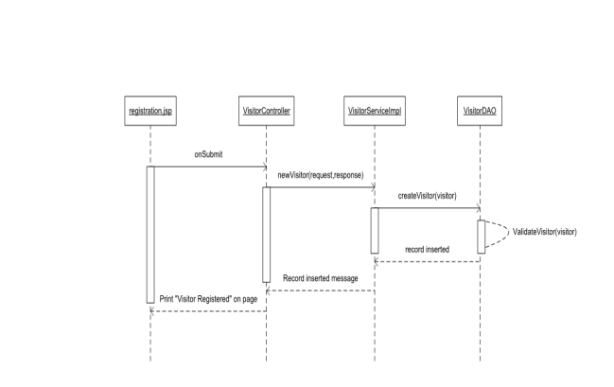 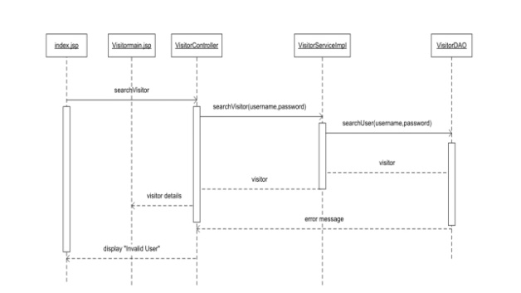

Update Visitor:- Event Registration:-

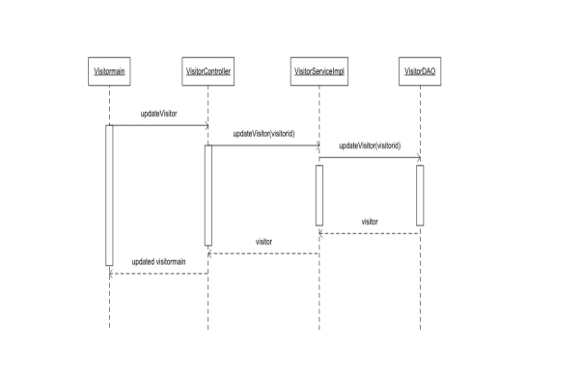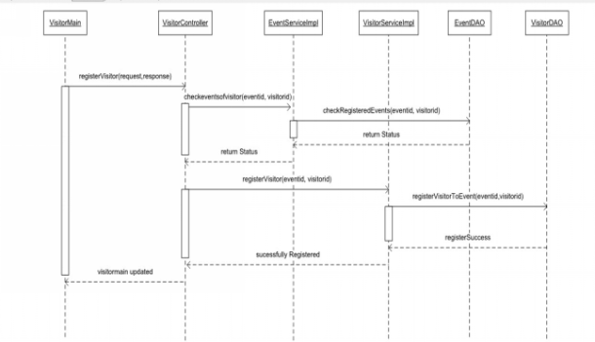

Unregister Form Event:-

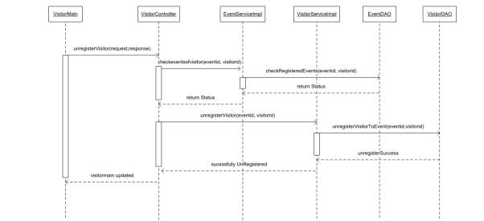



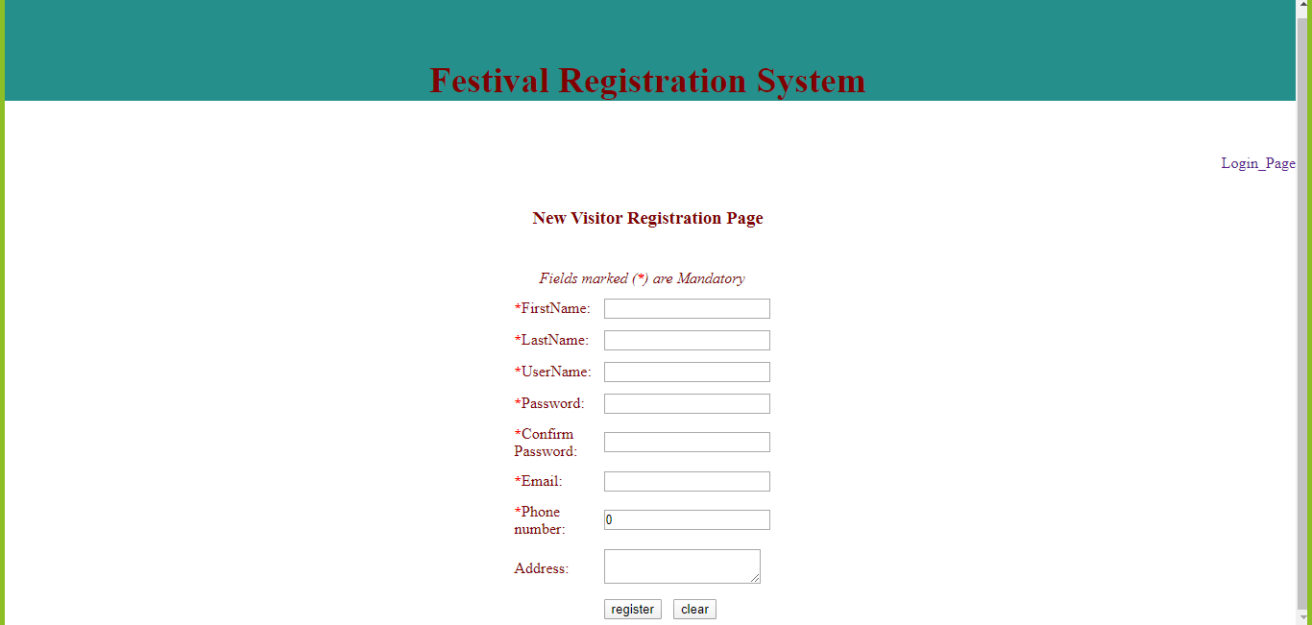

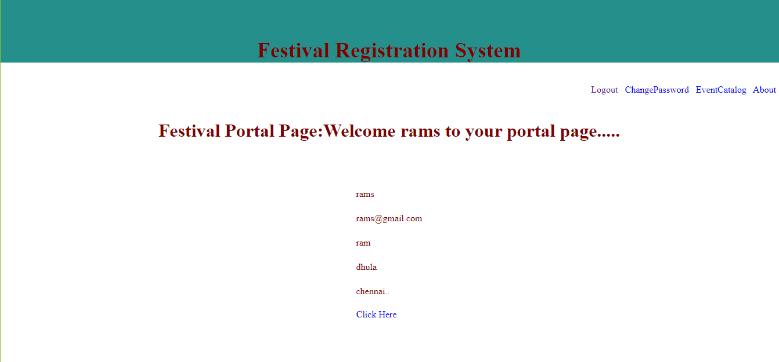



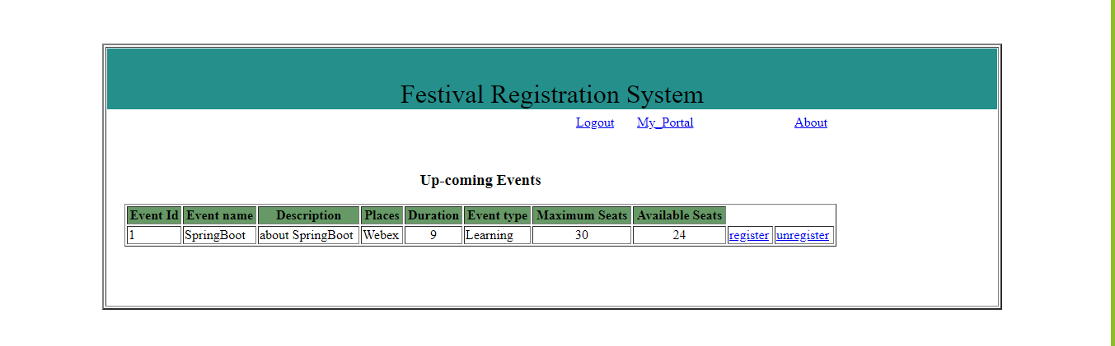

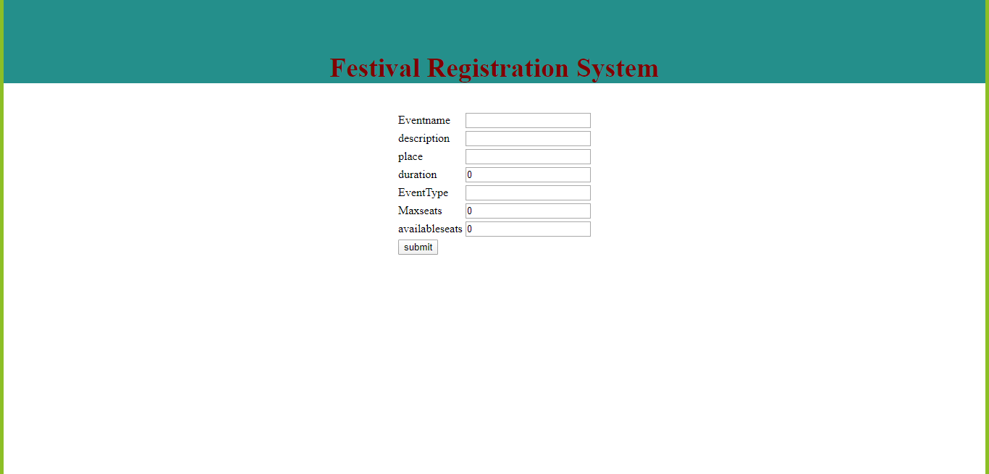

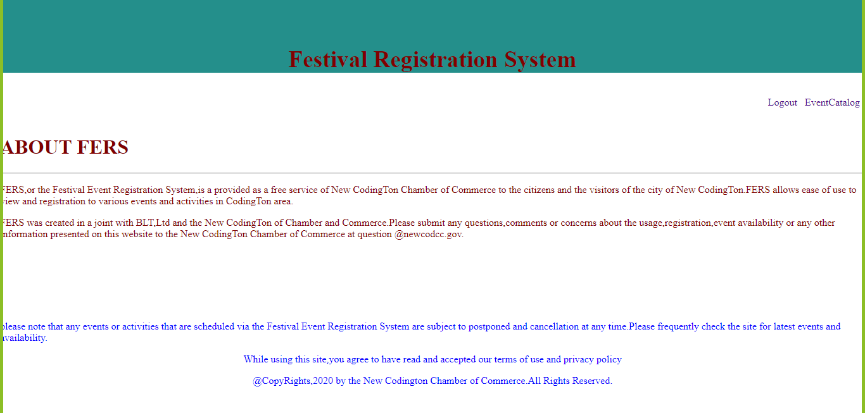

Conclusion and Future work:-

We have implemented this project in Monolithic architectural design. In future Scope we will implement this project using micro services for each and every module as an independent service.

References:-

* <https://blog.capterra.com/8-free-and-open-source-event-registration-software/>
* <https://medium.com/hubilo-officil-blog/12-online-platforms-to-get-your-event-registrations-in-place-de7ab9c4e577>
* <https://spring.io/>
* <https://www.google.com/search?q=html+and+css+projects&oq=html+and+css&aqs=chrome.1.69i57j0l5.4614j0j7&sourceid=chrome&ie=UTF-8>
* <https://www.google.com/search?q=mysql&oq=mysql&aqs=chrome.0.69i59l2j69i65j69i60j0l2.1414j0j7&sourceid=chrome&ie=UTF-8>